Generative AI
Generative AI models are built using machine learning, especially deep learning techniques. The most common architecture is the Transformer, which powers models like GPT, BERT, and DALL·E.
These models learn by:
- Training on large datasets — like books, images, code, or audio.
- Understanding patterns — such as grammar in text or shapes in images.
- Generating new content — by predicting what comes next or filling in gaps.

Real-World Applications
Generative AI is transforming industries:
- Business: Automating emails, reports, meeting summaries.
- Design: Creating logos, mockups, and product concepts.
- Education: Tutoring, content creation, personalized learning.
- Healthcare: Synthesizing medical notes, generating synthetic data.
- Entertainment: Writing scripts, composing music, generating game assets.
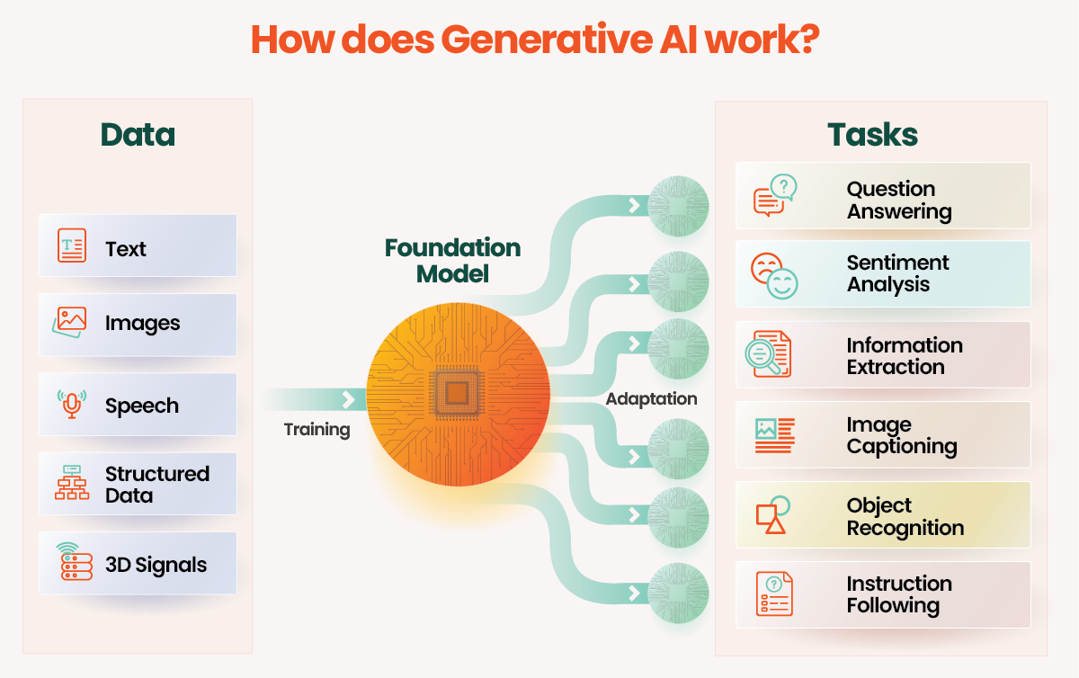
Challenges & Considerations
- Bias: AI can reflect biases in training data.
- Copyright: Generated content may resemble copyrighted material.
- Misinformation: AI can generate convincing but false information.
- Ethics: Deepfakes and impersonation risks.

Types
Text Generation
- Purpose: Produces human-like text.
- Models: GPT (OpenAI), Claude (Anthropic), Gemini (Google), LLaMA (Meta)
- Uses: Chatbots, writing emails, summarizing documents, translating languages, generating stories or reports.

2. Image Generation
- Purpose: Creates realistic or artistic images from text prompts.
- Models: DALL·E, Midjourney, Stable Diffusion
- Uses: Graphic design, concept art, marketing visuals, product mockups.

3. Audio & Music Generation
- Purpose: Composes music or generates speech/audio.
- Models: MusicLM (Google), Jukebox (OpenAI), ElevenLabs (for voice)
- Uses: Background music, voiceovers, sound effects, personalized audio content.

4. Video Generation
- Purpose: Produces short video clips from text or image inputs.
- Models: Runway ML, Sora (OpenAI), Pika Labs
- Uses: Marketing videos, animated stories, educational content.

5. Code Generation
- Purpose: Writes or completes programming code.
- Models: GitHub Copilot (powered by Codex), CodeWhisperer (Amazon)
- Uses: Software development, debugging, learning to code, automating tasks.

6. Data & Simulation Generation
- Purpose: Creates synthetic data for training or testing.
- Models: GANs (Generative Adversarial Networks), Diffusion Models
- Uses: Medical research, simulations, privacy-preserving data sharing.

7. Speech Generation
- Purpose: Converts text to natural-sounding speech.
- Models: Tacotron, WaveNet, VALL-E
- Uses: Virtual assistants, audiobooks, accessibility tools.

